Ms.Smita Yashawant Aparadh | 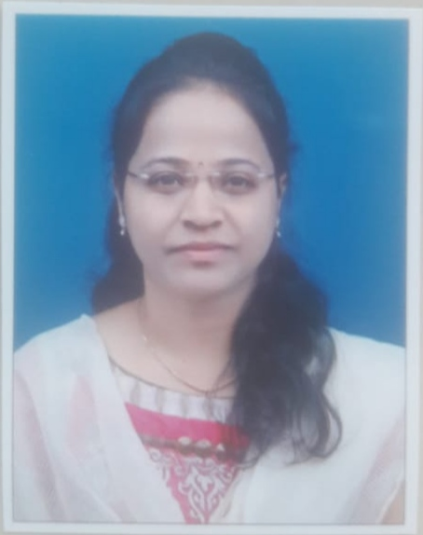
Mobile No: 8421150165
e-mail: smitaaparadh@gmail.com
Address: A/P Pattankodoli, Tal-hatkanangale,
Dist -Kolhapur

Objective |  | To join an organization where I can contribute and strive towards technical excellence through dedication and optimism. To refine my knowledge and skills, this will give direction to my goal as a technical professional.
Competencies |  | High ethical values Quick learner  Technical expertise Decision-making ability
IT Skills |  | - OS: Windows, Linux.  - DBMS: SQL.  - Programming Languages: C, C++  - Applications: MS Office.
Educational Qualification:

Level | University/Board | Course/  Specialization | Year of Passing | Percentage/  CGPA
M. Tech | S.V.College of Egg.& Technology (JNTU University, Hyderabad) | Computer Science and Engineering | 2014 | 79.62%
BE | TKIET, Warananagar (Shivaji University) | Computer Science and Engineering. | 2010 | 60.00%
XII | Maharashtra State Board | PCMB | 2006 | 74.17%
X | Maharashtra State Board | - | 2004 | 85.20%

Workshops Attended | - Completed 12 week online workshop of NPTEL on Automata Theory in March 2023.  - Online Two weeks national level faculty development programme on "Innovative Teaching Strategies and Tools in the Digital Age" from May 20 to June 02, 2023 b In Collaboration with Ministry of Education’s Institution Innovation Council (IIC GGI Ludhiana) Gulzar Group of Institutes Ludhiana (Punjab).  - Institution Innovation Council (IIC GGI Ludhiana)  - Gulzar Group of Institutes Ludhiana (Punjab)  - Completed 1 week workshop on SSTP on “Teaching Learning Process and NBA Accreditation Awareness” in Ashokrao Mane Polytechnic, Vathar in 2015.  - Completed 1 week workshop on SSTP on “Teachers Training Program in Ashokrao Mane Polytechnic, Vathar in 2015  - Completed three days’ workshop on improving “Teaching Pedagogy” organized by J.J.Maddum College in 2010  - Completed two days’ workshop on “Ad-hoc Networking and NS2 ” organized by RIT college in 2011  - Completed one day workshop on “faculty development program ” organized by AMGOI college in 2012  - Completed one day workshop “Developing skills in teaching methodology “ organized by Y.D.Mane college , Kagal in 2015  - Successfully completed one week online FDP on "Linux” organized from13/4/2020 to 18/04/2020 by Dr. J. J. Magdum collage of engineering, jaysingpur in association with spoken tutorial IIT, Bombay.  - Successfully completed one week online FDP on “Python 3.4.3" from 26/4/2020 to 2/5/2020 by PVPIT, Budhgav in association with spoken tutorial IIT Bombay.  - Successfully completed a one week FDTP on “Outcome based Education and NBA accreditation process " from 4/5/2020 to 8/5/2020 by RIT, Rajaramnagar.  - Participated in 3 days FDP on “online platform for Distance Education" from 12/5/2020 to 14/5/2020 by RIT, Rajaramnagar.  - Successfully completed MSBTE sponsored one week online FDP on " NBA norms and preparation of SAR - criteria 1-9 from 25/5/2020 to 29/5/2020 by RIT, Rajaramnagar.  - Successfully completed 3 days STTP on “Software as a Service" from 5/6/2020 to 7/6/2020 by Annasaheb Dange college of Engineering, Ashta.  - Successfully completed one-week National Level Online FDP on “Effective use of ICT Tools in Teaching Learning Process. from 8/6/2020 to 12/6/2020 by DTE Maharashtra and MSBTE” organized by Government Polytechnic, Malvan.  - Participated in Three Days Online FDP on “Research Methodology & Research Paper Writing” from 14/6/2020 to 16/6/2020 by Department of Electrical Engineering, RIT Rajaramnagar.  - Attended Online One Day National Webinar on “Give Wings to Your Students: Be a Mentor, be a Role Model” on 23/6/2020.by RIT, Rajaramnagar & Global Engineering Dean’s Council India Chapter (GEDS India Chapter).  - Attended online One Day Webinar on “Leadership and Governance from NBA Perspective” on 13/6/2020.by organized by Department of Humanities, Sou. Venutai Chavan Polytechnic, Pune.  - Participated 5 days online FDP on “Renewable Energy Sources” from 7/12/2020 to 11/12/2020 by Department of Electrical Engineering K. K. Wagh Polytechnic, Nashik -03.  - Participated and completed successfully AICTE Training and Learning Academy Online 5 days FDP on “Cyber Security” from 30/11/2020 to 4/12/2020 by Sri Venkateswara Collage of Engineering ATAL.  - Participated and completed successfully AICTE Training and Learning Academy Online 5 days FDP on “Artificial Intelligence” from 7/12/2020 to 11/12/2020 by Sri Sai ram Engineering Collage ATAL.
Conferences Attended | - Attended National Conference on Emerging Trends in Engineering and Technology (NCETET 2015) organized by AMGOI
Papers Published | - A survey on Security Prospect through Multicloude Computing by Adapting Data Splitting has been published in volume 3 Issue 11, November 2014 in International Journal of Science and Research(IJSR)  - Survey on Security Prospect through Multicloude Computing by Adapting Data Splitting has been published in AES Journals in Engg.  - A study of a “Detection and Elimination of Data Inconsistency in Data Integration” in International Journal of Science and Research in Science, Engineering and Technology (IJSRSET)
Experience | - 1 year teaching experience in AIT, Vita from 2010- 2011  - 3 year teaching experience in AMP, Ambap from 2011 to 2015  - 4 year Teaching experience in AMP, Vathar from 2015 to 2019  - 3 year teaching experience in AMGOI, Vathar from 2019 to March 2022  - Worked in TKIET, Warana from 1/09/22 to 30/06/2023.  - Now working in Sharad Institute of Technology college of Engineering, Yadrav from 1/7/2023.
Work Done | Examination Related Work  - Worked as Examiner In charge in Amp, Ambap for Summer 2014  - Worked as Controller Examiner in D.Y.Patil , Bavada for Winter -2015  - Conducting class test Examination  - Worked as Invigilator for MSBTE Theory Exam from 2014.  - Worked as Evaluator Of Answer Script for MSBTE Theory Exam from 2014.  - Worked as Exam Coordinator in department level in TKIET.  - Worked as NPTEL Coordinator in department level in TKIET.  Curricular Related Work  - Working as Departmental NBA coordinator from 2015.  - Worked as I/C HOD for one year In AMP, Ambap (2014-15)  - Worked as Time Table In charge  - Worked as Class Teacher, mentor  - Worked as Event Manager in “TECHNO-CHAMP” 2013 and workshop held in 2013 for two days  - Worked as a NSS Departmental coordinator.  - Organized NSS one day camp for tracking in 2015  - Worked as team member in static career fair at AMP. Ambap in 2014  - Worked as member of Computer Society of India for one year in (2014) (Membership No- N1222247)  - Organized “International Day of Yoga” for two days at AMP, Vathar for 2 years 2015-2016  - Worked as In plant Training IN charge from 2015  - Arranged International Yoga Day from 2015-16  Social Work Activity  - Working as Art of Living Teacher from 2015-16
Personal Details | Name :- Smita Yashwant Aparadh  Date of Birth: 20/11/1988  Address: A/P Pattankodoli,  Tal- Hatkanagle Dis- Kolhapur

Declarations: - I hereby declare that the above written particulars are true to the best of my knowledge & belief.
Place:
Date: Miss Aparadh S.Y.

